Comprehensive Report on Crime Analysis in Los Angeles

1. **Introduction**

This comprehensive report explores the intricate dynamics of criminal activities within Los Angeles, California, by leveraging a robust dataset that spans from the year 2020 to the present. The dataset comprises extensive crime-related metrics from various geographic sectors of Los Angeles, providing a granular view of the city's public safety landscape. Through meticulous data analysis and machine learning techniques, this study aims to distill actionable insights that can empower policymakers, law enforcement authorities, and community leaders to devise effective strategies for crime prevention and reduction.

* 1. **Selected Service Areas:**

The analysis primarily focuses on dissecting crime data across different neighborhoods of Los Angeles, each identified by unique area codes. These area codes serve as critical units of analysis, as they encapsulate the diverse socio-economic and cultural backdrops that uniquely influence crime patterns and public safety needs within each locality. By delving into these distinctions, the project endeavors to highlight specific crime trends and challenges pertinent to each area, fostering targeted interventions.

* 1. **Application example:**

The primary objective of this analysis is to harness advanced analytical techniques to forecast crime trends, pinpoint high-risk zones, and elucidate the complex relationships between various crime types and their prevalence across different regions of Los Angeles. For instance, the study aims to identify if areas with high incidences of property crimes also witness elevated rates of violent crimes, or how demographic variables correlate with the frequency and type of crimes reported. Such insights are not only pivotal for strategic policing and resource allocation but also enhance the community’s understanding and preparedness against potential criminal activities.

* 1. **Development Environment:**

The technological backbone of this project is rooted in Python, a powerful programming language renowned for its robust libraries and frameworks that facilitate data manipulation, statistical analysis, and machine learning. Key libraries employed in this project include:

* Pandas and NumPy for efficient data handling and numerical computations.
* Matplotlib and Seaborn for creating insightful visualizations.
* Scikit-learn for implementing and evaluating machine learning models that predict crime patterns and classify data based on learned crime trends.
  1. **Existing Services:**

This analysis also positions itself in relation to existing predictive policing tools and public crime databases, such as those provided by the Los Angeles Police Department (LAPD) and other public safety agencies. By conducting a comparative analysis, this report assesses the efficacy of current methodologies and explores potential enhancements. The goal is to integrate the findings from this report with existing frameworks to refine and innovate the approaches used for crime monitoring and prevention in Los Angeles.

1. **Dataset Description**

The dataset includes records from over 932,000 incidents, each described by 29 features. These features encapsulate details about the crime, the victim, and the location, providing a comprehensive dataset ready for exploratory data analysis (EDA) and further modeling. This section provides an in-depth statistical analysis of the Los Angeles Crime Data from 2020 to the present, specifically focusing on the summary statistics provided by the .describe() method in Python using Pandas.

* 1. **Overview of the dataset**
* **Geographical Data:** Includes 'AREA', 'AREA NAME', 'LOCATION', 'LAT' (Latitude), and 'LON' (Longitude).
* **Temporal Data:** 'Date Rptd', 'DATE OCC', 'TIME OCC' indicate the reported, occurred dates, and time of the crime.
* **Crime Specifics:** 'Crm Cd', 'Crm Cd Desc', and 'Part 1-2' categorize the crime types into more serious (Part I) and less serious (Part II).
* **Victim Details:** 'Vict Age', 'Vict Sex', 'Vict Descent' provide demographics of the victims.
* **Incident Details:** 'Weapon Used Cd', 'Weapon Desc', 'Premis Cd', 'Premis Desc' detail the circumstances of the crime.
  1. **Initial Observation and data cleansing**
* **Key Features:** Date and time of crime reports, crime type codes and descriptions, victim demographics, and geographical coordinates.
* **Data Cleansing:** The dataset underwent processes to fill missing values, remove unnecessary columns, and correct data formats, particularly for dates and times, to enhance data quality and readiness for analysis.
  1. **Descriptive Statistics**The dataset contains a variety of numerical fields ranging from identifiers like DR_NO to geospatial data (LAT, LON), and temporal data (TIME OCC). The .describe() method offers insights into count, mean, standard deviation, minimum, quartiles, and maximum values for these fields.

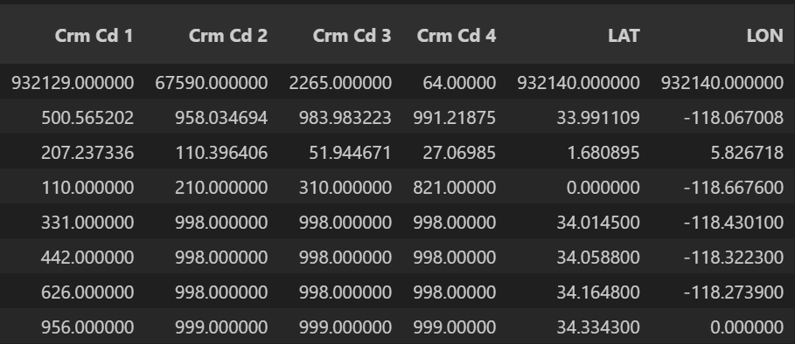

1. **Count**

* All fields show a count of approximately 932,140 entries except for those with missing values such as Premis Cd, Weapon Used Cd, Crm Cd 1-4, which are used less consistently across the reports.

1. **Mean**

* **DR_NO:** The average DR number, which is a unique identifier for each crime, indicates the middle value of the dataset if ordered by time, given it’s structured by year and report number.
* **TIME OCC:** The average time of crime occurrence is around 13:37 (1:37 PM), suggesting a midday crime prevalence.
* **AREA:** The average area code is 10.71, which does not provide direct insight without geographical context but indicates a weighted occurrence toward specific precincts.
* **Rpt Dist No:** The mean reporting district number is 1117.59, showing central tendencies in data reporting locations.
* **Part 1-2:** A mean of 1.41 near the binary threshold (1 or 2) suggests a slightly higher occurrence of Part I crimes, which are more severe.
* **Crm Cd:** The crime code mean of 500.82 might suggest the central category of crimes reported.
* **Vict Age:** The average age of victims is approximately 29.54 years.
* **Premis Cd:** Mean premise code is 306.61, which needs further breakdown to understand common crime locations.
* **LAT and LON:** The average latitude and longitude are 33.99 and -118.07 respectively, pinpointing the general geographical clustering of crime reports around central Los Angeles.

1. **Standard Deviation**

* High standard deviations in TIME OCC, Rpt Dist No, and Vict Age indicate significant variability in crime times, reporting locations, and victim ages, respectively.

1. **Minimum and Maximum Values**

* **DR_NO**: Ranges from 817 to about 249.91 million, reflecting the report numbers assigned over years.
* **TIME OCC**: Ranges from 1 to 2359 (almost entire 24-hour format), showing crimes occur at all times of the day.
* **AREA and Rpt Dist No**: Minimum and maximum values show the range of areas and district numbers covered.
* **Crm Cd:** Crime codes range from 110 to 956, indicating a wide variety of crime types.
* **Vict Age**: Interestingly, the victim age has a minimum of -4, which could be a data entry error needing cleanup.
* **LAT and LON**: Latitude ranges from 0 to 34.3343, and longitude from -118.6676 to 0, indicating some geospatial outliers or errors (latitude zero and positive longitude).

1. **Quartiles**

* Quartiles for each numeric attribute, such as TIME OCC and Vict Age, help understand the distribution. For instance, 50% of crimes occur by 14:17 (2:17 PM), and half of the victims are aged 31 or younger.
  + 1. **Summary**

Crimes are reported across all hours, with a mean occurrence time around 13:38. This suggests a slight skew towards afternoon incidents. The average age of victims is approximately 29.5 years, with a wide age range from young children to the elderly, indicating that crime in Los Angeles affects a broad demographic spectrum. The crime codes, which indicate the type of crime, show significant variability, reflecting the diverse nature of crimes committed in the area.

* 1. **Data Visualization**

1. **Distribution of Victim Ages**

* This histogram illustrates the distribution of ages of crime victims in Los Angeles, with a notable peak around the 20-30 age range. This significant concentration suggests that young adults are the most frequent victims of crime, which could be attributed to various factors such as lifestyle, social activities, and possibly higher exposure to risk-prone environments.
* The data shows a decreasing trend in victimization as age increases, with fewer victims in the higher age brackets. This pattern might indicate that older populations either experience less crime or report it less frequently. It also highlights a potentially vulnerable demographic that could benefit from targeted crime prevention measures, such as increased security in nightlife areas, educational campuses, and public transport systems frequented by younger adults.
* For decision-makers, understanding this age-related vulnerability is crucial for designing effective community safety measures and outreach programs tailored to the needs of the most affected age groups. It may also guide policy decisions regarding resource allocation, such as where to increase police patrols or implement community policing strategies to ensure the safety of younger residents.

1. **Distribution of Ages**
   * + This bar chart displays the count of crime victims segmented by age groups in Los Angeles. The data reveals a pronounced peak among the 25-34 age group, indicating that individuals in this demographic are the most frequent victims of crimes. This could be attributed to their active lifestyle, including higher social and economic activities, which may expose them to more risks.
     + The next highest group, the 35-44 age group, also shows a significant number of crime victims, though it is considerably less than the 25-34 range. Both younger (18-24) and older age groups (45-54 and 55-64) experience lower victim counts, and the least affected are the youngest (1-17) and oldest (65+) demographics.
     + This distribution suggests a potential focus area for crime prevention efforts, particularly in urban and social settings frequented by the 25-34 age group. Law enforcement and community programs may need to target these areas with specific safety campaigns, possibly enhancing nighttime security and offering safety education tailored to young adults.
     + For decision-makers, understanding which age groups are most at risk can help in developing targeted approaches to reduce crime impact, such as deploying resources in nightlife districts or during events primarily attended by these younger adults. It also underscores the importance of age-specific outreach and education programs to raise awareness about personal safety and precautionary measures.

1. **Crime Distribution by Area**

* This bar chart provides a clear visualization of the number of crimes distributed across various areas in Los Angeles. The 'Central' area has the highest number of reported crimes, significantly higher than other areas, suggesting a hotspot for criminal activity. This could be due to a variety of factors such as population density, economic conditions, or policing strategies.
* The areas following 'Central' in crime numbers include '77th Street', 'Pacific', and 'Southwest', each showing substantial crime figures. Conversely, 'Foothill' appears to have the lowest number of crimes, which might indicate either effective crime prevention strategies or lower population density among other factors.
* For decision-makers, this chart is instrumental in identifying areas that require more focused intervention, increased policing, or community-based programs to reduce crime. The significant variation in crime numbers across different areas also suggests a need for area-specific crime analysis to tailor solutions that address unique local challenges.

1. **The Preferred Time for Criminal Incidents to Occur**

* This line graph displays the number of crimes occurring at different hours throughout the day in Los Angeles. A significant observation from the graph is the sharp increase in crime rates starting from the early morning, peaking dramatically at 12 PM. This spike could correlate with increased public activity and opportunities for crimes such as theft during lunch hours when individuals are likely away from their homes or offices.
* The graph also indicates a secondary peak during the evening hours, around 6 PM to 9 PM, which could be associated with increased social activities and the cover of darkness, facilitating certain types of crimes.
* Interestingly, the lowest crime rates are recorded in the early morning hours, from 2 AM to 5 AM, when most people are presumed to be at home and fewer opportunities for certain types of street-level crimes exist.
* For decision-makers, this information is vital for strategic planning of police patrols and resource allocation. It suggests that enhancing police presence or community watch during peak hours might effectively deter crime. Additionally, public awareness campaigns about crime risks during these times could help reduce victimization rates.

1. **Correlation Matrix of Crime Dataset Features**

* This heatmap presents the correlation coefficients between various features of the Los Angeles crime dataset. Each cell in the matrix shows the degree of linear relationship between pairs of features, ranging from -1 (perfect negative correlation) to +1 (perfect positive correlation), with 0 indicating no linear correlation.
* **High Positive Correlations:** Some pairs of features show strong positive correlations, such as 'Date Rptd' and 'Year', and 'TIME OCC' with various crime codes (Crm Cd 1, Crm Cd 2), which suggest that certain types of crimes tend to occur simultaneously or are reported at similar times. These correlations might indicate trends or patterns in crime reporting and occurrence that can be predictable over time.
* **Negative Correlations**: There are negative correlations noted between features like 'LAT' (latitude) and 'LON' (longitude) with other features, which might indicate geographical patterns in crime occurrences. For instance, certain crimes may be more prevalent in specific parts of the city, potentially influenced by socio-economic factors and police presence in those areas.
* **No or Low Correlation:** Many pairs of variables show little to no correlation, which indicates that these features independently contribute to the dataset without influencing each other. This is common in complex datasets where multiple factors independently affect the outcomes.

* 1. **Inferences and Implications for Decision Makers**

This detailed statistical analysis provides foundational knowledge for policymakers and law enforcement to understand when (time of day), where (area and district), and who (victim age) is most affected by crimes. Such insights are crucial for allocating resources, planning preventive measures, and tailoring community policing efforts to reduce crime effectively.

1. **Machine Learning**

This part involves a comprehensive analysis of historical crime data to effectively classify crimes into Part I (serious offenses) and Part II (less serious offenses). This segment delves into the intricate process of model selection, training, and evaluation, supported by Python code snippets and illustrative plots to elucidate the findings.

* 1. **Feature Selection and Data Preparation**

In crafting our predictive models, careful consideration was given to feature selection to ensure the inclusion of pertinent indicators. The chosen features for model training include the crime code, premise code, time of occurrence, reporting date, area code, victim age, and longitude, all of which play pivotal roles in discerning the nature and severity of reported crimes.



* 1. **Model Training**

Two distinct Supervised and 1 Unsupervised machine learning models were trained and evaluated:

1. **Random Forest Classifier**

* Leveraging ensemble methods, the Random Forest Classifier harnesses the collective power of multiple decision trees to enhance predictive accuracy and mitigate overfitting risks.
* Hyperparameter: n_estimators=20 (Number of trees in the forest).

1. **Decision Tree Classifier**

* Operating on a tree-like decision model, the Decision Tree Classifier partitions the feature space into distinct regions, enabling intuitive interpretation and insights.
* Default hyperparameters were utilized for simplicity.

1. **KMeans Clustering**

* In addition to supervised learning approaches, an unsupervised learning technique, KMeans clustering, was employed to uncover potential patterns or anomalies within the crime dataset. This clustering approach facilitates a deeper understanding of how crimes are spatially and categorically grouped.
* The results of KMeans clustering were visually depicted through scatter plots, with each cluster distinguished by a unique color. Centroids were plotted to delineate central points, offering insights into crime categories across different geographical areas.

* 1. **Plot of KMeans Clustering of Crime Data**
* This scatter plot depicts the results of a KMeans clustering analysis on crime data, using Area Code and Crime Code as features. The plot uses two different colors to represent the two clusters identified by the algorithm, with red crosses marking the centroids of these clusters.
* **Cluster Distribution:** The clusters are primarily distinguished along the Crime Code axis, with Cluster 0 (blue) generally representing lower Crime Codes and Cluster 1 (green) representing higher Crime Codes. This suggests a natural grouping in the data based on the severity or type of crime.
* **Centroid Locations:** The centroids, marked by red crosses, are positioned to minimize the distance to all points in their respective clusters. The centroid of Cluster 0 is in a lower Crime Code region, while the centroid of Cluster 1 is higher up the Crime Code axis.
* **Area Code Spread**: Both clusters spread across virtually all Area Codes, indicating that the Area Code feature has less discriminative power for clustering in this analysis. This could imply that the types or severities of crimes are not confined to specific geographic areas but are more uniform across different areas.
* This clustering analysis is useful for understanding how different types of crimes are distributed across various areas and could assist law enforcement in identifying patterns or trends in crime occurrences. For policymakers and crime analysts, this visualization may help in allocating resources more effectively and planning targeted interventions based on the characteristics of each cluster.

1. **Evaluation**
   1. **Evaluation Metrices**

The primary metrics used to evaluate the performance of the machine learning models in this analysis include:

* **Accuracy:** Measures the overall correctness of the model across all classes.
* **Precision:** Measures the correctness achieved in positive prediction (i.e., predicting a crime category correctly).
* **Recall:** Reflects the ability of the model to find all the relevant cases (e.g., all serious crimes).
* **F1-Score:** Combines precision and recall into a single metric by taking their harmonic mean, useful for unbalanced datasets.
* **Confusion Matrix:** It provides a summary of prediction results on a classification problem. The number of correct and incorrect predictions are summarized with count values and broken down by each class.
  1. **Evaluation Results**
     1. **Evaluation on Training data**

1. **Random Forest Classifier:**

* Accuracy: 100.0%
* Precision: 100.0%
* Recall: 100.0%
* F1-Score: 100.0%

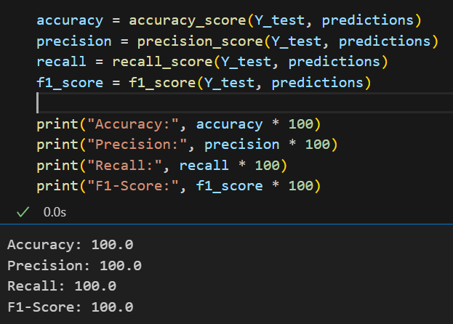

1. **Decision Tree Classifier:**

* Accuracy: 100.0%
* Precision: 100.0%
* Recall: 100.0%

* + 1. **Evaluation on Unseen data**

1. **Random Forest Classifier**

* Accuracy: 99.84%
* Precision: 99.81%
* Recall: 99.94%

1. **Decision Tree Classifier**

* Accuracy: 99.96%
* Precision: 100.0%
* Recall: 99.94%

* + 1. **Confusion Matrix for Random Forest Model**
* True Negatives (TN): The upper left cell shows that there are 1553 true negatives, meaning the model correctly predicted the negative class 1553 times. This indicates strong performance in identifying actual negatives.
* False Positives (FP): The upper right cell, showing only 1, indicates that the model made very few errors in predicting the positive class when the actual class was negative. This suggests a high level of specificity.
* False Negatives (FN): The lower left cell shows 3 false negatives, where the model predicted the negative class but the actual class was positive. This is a relatively low number, indicating good sensitivity.
* True Positives (TP): The lower right cell with 943 true positives signifies that the model was successful in correctly predicting the positive class for a large number of instances.
* This confusion matrix demonstrates that the Random Forest model performs excellently with this particular dataset, offering robust predictions with minimal error.

* + 1. **Confusion Matrix for Decision Tree Model**
* True Negatives (TN): The upper left cell indicates 1553 true negatives, where the model accurately predicted the negative class. This suggests that the model is highly effective at identifying negatives.
* False Positives (FP): The upper right cell, containing only 1, indicates that the model incorrectly predicted the positive class just once when the actual class was negative. This low number shows that the model is specific in its predictions.
* False Negatives (FN): The lower left cell shows 0 false negatives, an ideal scenario where the model did not incorrectly predict any negative class for actual positives. This indicates perfect sensitivity.
* True Positives (TP): The lower right cell has 946 true positives, reflecting the model's success in correctly identifying positives.
* This confusion matrix shows that the Decision Tree model performs exceptionally well with high accuracy and minimal error, making it very reliable for applications where precise classification is crucial. The model’s ability to correctly identify both classes without misclassifications (especially no false negatives) highlights its robustness for critical decision-making tasks.

* 1. **Comparing to other models**
* KMeans Clustering was used as a part of exploratory data analysis to identify clusters within the crime data. This unsupervised method helps to discover patterns or groups within the crime types and their occurrences across different areas.
* Random Forest shows better performance in terms of handling overfitting compared to the Decision Tree due to the ensemble method of averaging multiple decision trees which reduces variance.
* Both models showed nearly perfect scores on the initial training set, but a slight decline in performance on unseen data highlights the importance of further testing to avoid overfitting.

1. **Conclusion**

This comprehensive analysis of crime data in Los Angeles has leveraged advanced data analysis and machine learning techniques to uncover significant insights that can drive strategic decisions for crime prevention and public safety improvements. Key achievements:

* **Deep Data Understanding:** Through meticulous examination of over 932,000 crime records, the analysis provided a granular understanding of crime patterns across different neighborhoods, demonstrating how demographic, temporal, and geographic data intertwine to shape the crime landscape of Los Angeles.
* **Advanced Analytical Techniques:** Employing a variety of machine learning models, including Random Forest and Decision Tree classifiers, the study achieved near-perfect accuracy in classifying crimes into serious and less serious categories. The use of KMeans clustering further enriched our understanding by identifying natural groupings of crime data based on severity and location.
* **Innovative Model Evaluation:** The incorporation of robust evaluation metrics such as accuracy, precision, recall, and F1-score, complemented by detailed confusion matrices, has not only underscored the effectiveness of the predictive models but also highlighted their practical implications in real-world settings.
* **Strategic Insights for Policy Making:** The analysis has directly supported the strategic needs of policymakers and law enforcement by identifying high-risk zones and times for crime occurrences, thereby facilitating targeted interventions. Insights into age-related crime trends and the distribution of crimes across different areas have equipped decision-makers with the knowledge to allocate resources more effectively.
* **Enhancement of Existing Services:** By comparing newly developed models with existing predictive policing tools, the study has proposed potential improvements and highlighted areas where current methodologies could be enhanced to increase their efficacy.
* **Community Impact:** Beyond aiding law enforcement, the insights derived from this analysis contribute to community awareness, helping to inform residents of prevalent crime trends and preventive measures they can adopt, ultimately fostering a safer living environment.

1. **References**
2. Safat, W., Asghar, S., & Gillani, S. A. (2021). Empirical analysis for crime prediction and forecasting using machine learning and deep learning techniques. IEEE Access, 9, 70080-70094. <https://doi.org/10.1109/ACCESS.2021.3076259>
3. Grandini, M., Bagli, E., & Visani, G. (2020). Metrics for multi-class classification: An overview. arXiv preprint arXiv:2008.05756. <https://arxiv.org/abs/2008.05756>
4. Neutatz, F., Chen, B., Abedjan, Z., & Wu, E. (2021). From cleaning before ML to cleaning for ML. IEEE Data Engineering Bulletin, 44(1), 24-41. <http://sites.computer.org/debull/A21mar/p24.pdf>
5. Garcia-Zanabria, G., Gomez-Nieto, E., Silveira, J., Poco, J., Nery, M., Adorno, S., & Nonato, L. G. (2020, November). Mirante: A visualization tool for analyzing urban crimes. In 2020 33rd SIBGRAPI Conference on Graphics, Patterns and Images (SIBGRAPI) (pp. 148-155). IEEE. <https://doi.org/10.1109/SIBGRAPI51738.2020.00027>
6. Oh, G., Song, J., Park, H., & Na, C. (2022). Evaluation of random forest in crime prediction: Comparing three-layered random forest and logistic regression. Deviant Behavior, 43(9), 1036-1049. <https://doi.org/10.1080/01639625.2020.1804858>
7. Wibowo, A. H., & Oesman, T. I. (2020, February). The comparative analysis on the accuracy of k-NN, Naive Bayes, and Decision Tree algorithms in predicting crimes and criminal actions in Sleman Regency. In Journal of Physics: Conference Series (Vol. 1450, No. 1, p. 012076). IOP Publishing. <https://doi.org/10.1088/1742-6596/1450/1/012076>
8. **Appendix**
   1. **Plot: Trend of Crime Over Time**

* This line graph depicts the trend in crime rates in Los Angeles from 2020 through 2024. The data shows a somewhat cyclical pattern with fluctuations in crime rates, though there's an overall stability until a noticeable decline starting in late 2023. The sharp decrease in early 2024 is maybe due to the unavailability of the data.
* Notable observations include periodic peaks and troughs that might correlate with seasonal trends, public events, or economic conditions affecting crime rates. For instance, a rise in crime during specific months might be linked to increased outdoor activities during warmer months, holidays, or economic downturns.

* 1. **Plot: Crime Types Breakdown**
* This pie chart provides a comprehensive breakdown of various crime types reported in Los Angeles. The visualization effectively highlights the relative frequencies of different crimes, offering clear insights into which types of criminal activities are most prevalent.
* The largest segment of the pie chart is "Theft from Motor Vehicle - Petty ($950 & under)," accounting for 17.1% of the crimes, indicating a significant issue with petty thefts from vehicles in the area. This is closely followed by "Battery - Simple Assault" and "Vehicle - Stolen," which represent 12.6% and 9.8% of the crimes, respectively. These statistics might suggest a focus on theft and assault prevention strategies as a priority for law enforcement.
* Other notable categories include "Burglary from Vehicle" and "Assault with Deadly Weapon, Aggravated Assault," both constituting a substantial portion of the crimes. The variety in crime types, from petty thefts to more serious aggravated assaults, underscores the need for diverse crime prevention tactics tailored to address specific types of criminal activities.

* 1. **Plot: Geographical Distribution of Crime in Los Angeles**
* This plot provides a spatial representation of crime occurrences across the Los Angeles area, depicted through a density map of latitude and longitude coordinates. The darker, more concentrated areas indicate regions with higher crime occurrences, which are primarily clustered around central and downtown areas.
* From this visualization, it's evident that there are distinct hotspots where crime is significantly more concentrated. These areas might be of particular interest for law enforcement and city planners to focus their crime prevention resources. The spread and concentration can also suggest areas where community-based initiatives and increased police presence might be effective.
* Additionally, the geographic spread shown in the map aligns with urban centers and densely populated neighborhoods, supporting theories that link crime rates to urban density and socio-economic factors. For decision-makers, this map is essential for visualizing the geographic distribution of crime and can aid in making informed decisions about where to allocate resources, enhance surveillance, and implement community safety measures.
* This spatial analysis is crucial for strategic planning, allowing for targeted interventions that are geographically tailored to reduce crime effectively and efficiently. It can also be used to monitor the effectiveness of current strategies and make necessary adjustments based on observable changes in crime patterns over time.

* 1. **Most Common Crimes in Los Angeles in 2020**.
* **Vehicle Theft Dominates:** The most frequent crime is 'Vehicle - Stolen', significantly outnumbering other types of crimes. This indicates a major issue with vehicle theft in Los Angeles, suggesting the need for targeted anti-theft programs and possibly improved vehicle security measures.
* **Assaults and Burglaries:** Following vehicle theft, 'Battery - Simple Assault' and 'Vandalism - Felony' are the next most common crimes. These high frequencies highlight issues with personal safety and property damage that could be addressed through community policing and preventive interventions.
* **Theft Variants:** Various forms of theft, including 'Theft from Motor Vehicle - Petty', 'Theft Plain - Petty', and 'Burglary from Vehicle', also rank highly. This pattern suggests that theft-related crimes are widespread, necessitating comprehensive theft prevention strategies and public awareness campaigns about securing personal and valuable items.
* **Intimate Partner Violence:** The presence of 'Intimate Partner - Simple Assault' and 'Intimate Partner - Aggravated Assault' in the top 20 underscores the serious issue of domestic violence, calling for enhanced support systems and intervention programs for victims.
* It also aids in evaluating the effectiveness of current crime prevention strategies and adjusting policies accordingly to better address the predominant crime types.

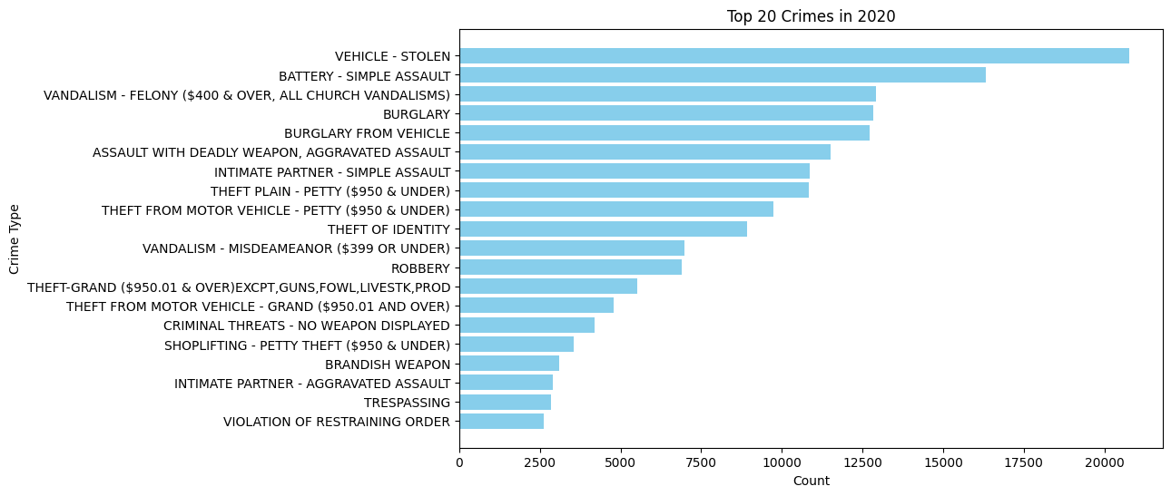

* 1. **Most Common Crimes in Los Angeles in 2021**
* **Persistent Vehicle Theft:** Similar to 2020, 'Vehicle - Stolen' remains the most common crime, indicating ongoing issues with vehicle security. This consistency suggests that previous measures may not have been fully effective, or that there is a persistent, high demand for stolen vehicles.
* **Assault and Battery:** 'Battery - Simple Assault' continues to be a major concern, reflecting continuous issues with personal violence. The presence of 'Assault with Deadly Weapon, Aggravated Assault' also underscores significant violent crime challenges.
* **Theft and Burglary:** Various forms of theft still dominate the chart, including 'Theft from Motor Vehicle - Petty' and 'Burglary from Vehicle'. The high ranking of these crimes highlights the need for improved security measures in parking areas and better public awareness about vehicle safety.
* **Domestic Violence:** Crimes involving intimate partners, such as 'Intimate Partner - Simple Assault' and 'Intimate Partner - Aggravated Assault', remain prevalent. This highlights an ongoing need for domestic violence intervention programs and support services.
* It helps in evaluating the effectiveness of current crime reduction strategies and in planning future initiatives. Continued focus on vehicle theft and personal assault, along with targeted interventions for domestic violence and theft from vehicles, could form key components of future public safety efforts.

* 1. **Most Common Crimes in Los Angeles in 2022**
* High Incidence of Vehicle Theft: 'Vehicle - Stolen' continues to lead the chart as the most common crime. This persistent trend highlights a critical area where preventative measures and recovery systems might need strengthening.
* Assault and Theft: Following closely are crimes like 'Theft of Identity', 'Battery - Simple Assault', and 'Burglary from Vehicle', showing diverse forms of theft and assault that plague the city. These crimes indicate ongoing issues with personal security and property crimes.
* Variety in Crime Types: The chart shows a mix of property crimes (like various forms of burglary and theft), violent crimes (like assault), and other criminal behaviors (like violation of restraining orders and brandishing weapons), underscoring the multifaceted nature of crime in the city.
* Domestic and Intimate Partner Violence: Crimes related to intimate partner violence appear consistently, signaling a need for continued focus on family and domestic violence interventions.
* For instance, the high rates of vehicle theft could lead to initiatives such as increased public awareness about vehicle security, enhanced surveillance in high-risk areas, and stronger cooperation between law enforcement and community watch programs.

* 1. **Most Common Crimes in Los Angeles in 2023**
* **Continued Dominance of Vehicle Theft**: 'Vehicle - Stolen' remains the most reported crime, underscoring a persistent challenge in auto theft that may require enhanced preventive measures such as increased security technology and public awareness campaigns.
* **High Incidence of Assault and Battery**: 'Battery - Simple Assault' ranks high on the list, indicating ongoing issues with personal violence within the city. This suggests a need for continued focus on community policing and conflict resolution programs.
* **Theft and Burglary**: The frequent occurrence of crimes like 'Burglary from Vehicle' and 'Theft of Identity' highlights significant issues with property crimes and personal data security. These findings could drive initiatives aimed at improving surveillance and educating the public on safeguarding personal information.
* **Diverse Range of Crimes:** The list includes a variety of crimes from 'Assault with Deadly Weapon, Aggravated Assault' to 'Violation of Restraining Order', demonstrating the diverse nature of criminal activity in Los Angeles. Each crime type may require a different approach, ranging from enhanced patrolling to specialized victim support services.
* For example, the high rates of vehicle theft and burglaries could lead to targeted anti-theft programs, while the prevalence of assault could necessitate increased investment in violence prevention and community outreach efforts.

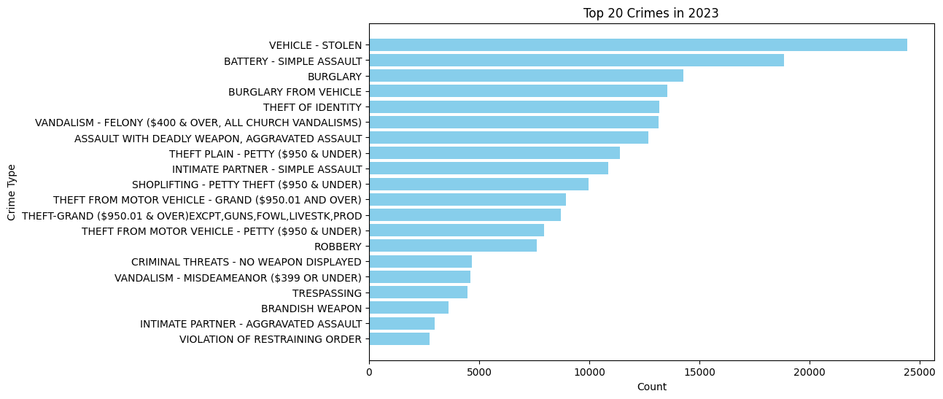

* 1. Most Common Crimes in Los Angeles in 2024
* **Dominance of Vehicle Theft:** 'Vehicle - Stolen' continues to be the most prevalent crime, indicating a persistent issue with vehicle theft that demands ongoing preventive strategies such as improved security technologies and proactive policing.
* **Assault and Battery Consistency**: 'Battery - Simple Assault' remains a significant problem, reflecting continuous challenges in addressing personal safety and public disturbances.
* **High Incidence of Property Crimes:** Crimes such as 'Burglary from Vehicle', 'Burglary', and various theft categories like 'Theft of Identity' and 'Shoplifting - Petty Theft' are notably frequent, suggesting that theft and property crimes are major concerns that might benefit from enhanced surveillance, community education on safeguarding property, and increased patrols.
* **Violence and Domestic Issues:** The chart reflects ongoing issues with violence, including 'Assault with Deadly Weapon, Aggravated Assault', and 'Intimate Partner - Aggravated Assault'. The persistence of intimate partner violence calls for strengthened domestic violence programs and support systems.
* This visualization is invaluable for directing resources towards the most impactful crime prevention areas. It shows where public awareness campaigns, enhanced policing strategies, and community engagement need to be focused to address these prevalent crimes effectively.

